**W. Phan/J. Wright**

**Updated K.R. Muller April 2018**

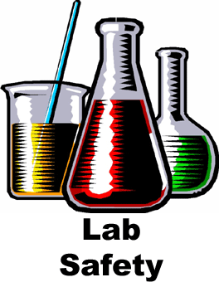

Pomona College Chemical Hygiene Plan

DRAFT – April 2018

This page intentionally left blank.

Table of Contents

Foreword 4

Roles and Responsibilities 5

Call List 7

General Lab Safety Rules 8

Personal Protective Equipment (PPE) and Safety Equipment 9

Biosafety, Laser Safety, and Radiation Safety 11

Safety Data Sheets (SDSs) 12

Chemical Hazard Classifications 14

Health and Environmental Hazards 14

Physical Hazards 15

Particularly Hazardous Substances (PHSs) 16

Hazardous Waste 17

Laboratory Injuries 18

Students 18

Employees (includes Student Workers) 19

Available Medical Services 20

Earthquakes 22

Laboratory Fires 24

Chemical Spills 27

Minor Chemical Spills 27

Major Chemical Spills: 28

Personnel Exposure 29

Appendix A: Medical Consultation/Surveillance 31

Appendix B: Lab-Specific SOP Template 32

Appendix C: Emergency Eyewash and Safety Shower Program 34

Appendix D: Accident Investigation Form 36

Appendix E: Peroxide Formers 39

Appendix F: Hazardous Waste Tag Format 40

Appendix G: General Chemical Incompatibility Matrix 41

# Foreword

Pomona College is committed to providing a safe working environment in academic and research laboratories for its employees. The purpose of the Chemical Hygiene Plan (CHP) is to make laboratory personnel aware of potentially hazardous chemicals and to provide guideline to work safely with hazardous chemicals. This plan is required by the State of California pursuant to Title 8, Section 5191 and the OSHA Laboratory Standard (29 CF 1910.1450).

Laboratory personnel are responsible for their own safety and are required to follow the guidance in this document and minimize the risks of potential exposures or release of hazardous materials while working in the lab. Departments may choose to go “above and beyond” this document and implement additional health and safety protocols. Implementation of the Chemical Hygiene Plan depends on the cooperation of department chairs, faculty, laboratory staff, students, The Claremont Colleges Services Office of Environmental Health & Safety, and members of safety committees.

# Roles and Responsibilities

**College President**The President of Pomona College has the final responsibility for the safety and health of the faculty, students, and staff working at the College.

**Vice President and Dean of the College**The Vice President and Dean of the College has assigned oversight responsibility for the Academic Chemical Hygiene Plan to Associate Dean Tony Boston. The Associate Dean has the responsibility and the authority to see that the Chemical Hygiene Plan is written, updated, and implemented.

***Office of Facilities and Campus Services*** *TBD*

***Assistant Director of Facilities and Housekeeping*** *TBD.*

**The Claremont Colleges Services Office of Risk Management and Benefit Administration**   
The Claremont Colleges Services Office of Risk Management and Benefit Administration work with faculty and staff to develop and implement appropriate policies and to ensure regulatory compliance. It also provides or arranges for training beyond that provided by Pomona EH&S as needed.

**The Office of Campus Safety**  
The Office of Campus Safety is the first responder to emergencies of any kind. It provides first aid until the arrival of paramedics and assist law enforcement and other emergency service providers as needed.

**Environmental Health and Safety Officer (EH&S Officer)**  
The Environmental Health and Safety Officer is an employee of Pomona College who is qualified by training and experience to provide technical guidance on the development and implementation of the provisions of the Chemical Hygiene Plan. The Environmental Health and Safety Officer has the following responsibilities:

a) Review and update the Chemical Hygiene Plan annually.

b) Investigate accidents and chemical exposures within the department.

c) Act as a liaison between the Department, Office of Facilities and Campus Services and The Claremont Colleges Services Office of Environmental Health and Safety for laboratory safety issues.

d) Maintain records of training, exposure monitoring, and medical examinations.

e) Ensure that students receive general lab and chemical safety training.

f) Assist in the development of SOPs for particularly hazardous substances.

g) Approve laboratory worker’s return to work following a chemical exposure requiring medical consultation.

**Department Chairs**  
Department chairs have the responsibility to ensure that the Chemical Hygiene Plan is implemented by faculty and laboratory supervisors in their departments. The responsibilities of the department chair include:

a) Ensure that all faculty and staff comply with the safety requirements of the department.

b) Ensure that an adequate number of spill kits are available in the department.

c) Maintain in the department office or library a set of Material Safety Data Sheets for toxic or hazardous chemicals used in the department, or ensure that all laboratory personnel have access to MSDSOnline.

**Faculty and Laboratory Supervisors**  
The laboratory supervisor or instructor for the course is the person responsible for the research laboratory and prep rooms. The primary responsibility of the supervisor is to implement the Chemical Hygiene Plan. Duties include the following:

a) Ensure that all work is conducted in accordance with the Chemical Hygiene Plan.

b) Identify potential laboratory hazards.

c) Ensure that all academic personnel (faculty, staff and students) who work with hazardous materials are familiar with, and have been trained in the requirements of, the CHP.

d) Request assistance as needed regarding hazard information or training.

e) Maintain an inventory of all hazardous chemicals under their control.

f) Develop and implement a chemical labeling program which assures that all hazardous substances are correctly labeled and appropriate warning signage is displayed.

g) Provide SOPs for the use of all particularly hazardous substances.

h) Ensure that all hazardous waste is handled in accordance with the College’s procedures.

i) Maintain a set of Safety Data Sheets for hazardous chemicals used in the laboratory space, or ensure that all laboratory personnel have access to MSDSOnline.

j) Ensure that all safety checks have been performed prior to the use of equipment.

k) Help with the clean-up of small spills as specified under Standard Operating Procedures.

l) Report incidents to the Environmental Health and Safety Officer or the Campus Safety Committee.

m) Ensure laboratory workers receive chemical and procedure-specific training.

# Call List

|  |  |  |
| --- | --- | --- |
| **Campus Department or Agency** | **Extension** | **Full Phone Number** |
| Campus Safety | X72000 | (909) 607-2000 |
| Environmental Health & Safety Officer | X77359 | (909) 607-7359 |
| TCCS Environmental Health & Safety | X77233 | (909) 607-7233 |
| TCCS Worker’s Compensation Administrator | X18847 | (909) 621-8322 |
| Director of Facilities | X74150 | (909) 607-4150 |
| Associate Dean’s Office | X18497 | (909) 621-8497 |
| Pomona Valley Health Centers Urgent Care |  | (909) 865-9977 |

# General Lab Safety Rules

**Personal Apparel & Hygiene**

1. Do not eat, drink, smoke, chew gum, or apply cosmetics or lip balm in the laboratory.
2. Do not store food or drink inside the laboratory unless it is used for experimental purposes. In such instance, label the food or drink as “**Laboratory use only**.”
3. Wash hands with soap and water whenever leaving the laboratory, changing work stations, or if you suspect there may have been skin contamination.
4. Do not touch common surfaces (door handles, computers, cell phones, etc.) with gloves or lab coats. Do not wear PPE outside of the laboratory unless needed to transport hazardous materials between lab areas.
5. Constrain long hair, loose clothing, and jewelry that might come in to contact with hazardous materials.
6. Avoid direct inhalation of chemicals; do not taste anything in the lab or pipet by mouth.

**Lab Practices & Housekeeping**

1. Never perform unauthorized experiments.
2. Do not work alone in the laboratory if procedures being done are hazardous.
3. Report violations of laboratory safety rules to your supervisor or the Responsible Person for the lab.
4. Avoid practical jokes or other behavior that might confuse, startle, or distract other laboratory personnel.
5. Keep work area neat and uncluttered. Clean up after each experiment.

**Labeling & Signage**

1. Provide appropriate warnings about hazards present or experiments in process and restrict laboratory entry to authorized personnel only.
2. Label all secondary chemical containers with their contents and associated hazards, including water.

**Chemical Storage & Safety**

1. Prior to using a chemical, make sure to read and understand the SDS and ensure that you have access to the SDS through MSDSOnline.
2. Do not store incompatible chemicals together (as designated by the SDS).
3. Clean up minor spills immediately, if it is safe to do so. See the **Minor Spills** section of the CHP.
4. Discard expired or unneeded chemicals as hazardous waste.
5. Label peroxide-forming or unstable chemicals with test-by/expiration dates and dispose of any expired containers. See the **Peroxide Formers** appendix.
6. Use secondary containers for storing or transporting chemicals.
7. Store flammable materials in a flammable cabinet or approved refrigerator when not in use. Up to 5 gallons of flammable materials are allowed on the lab bench. Keep flammable materials away from heat, ignition sources, and sources of sparks. Ground large (>5 gallons) containers during transfer.
8. Store corrosive materials in secondary containment inside a well-ventilated corrosive cabinet. Separate acids from bases, and organic acids from mineral acids. Never add water to a concentrated corrosive material. Corrosive materials should never be stored above eye-level.
9. Gas cylinders must be stored upright, chained at two points, and capped whenever not in active use.
10. When working in an area where cryogenic liquids are stored, always ensure there is sufficient ventilation, and an oxygen monitor if necessary, to avoid a buildup of gas leading to an oxygen-deficient atmosphere. To avoid burns, wear protective gloves when handling objects that come in contact with cryogenic liquids, or if there is a splash hazard.

## Personal Protective Equipment (PPE) and Safety Equipment

**Personal Protective Equipment (PPE)**  
The OSHA Personal Protective Equipment Standard (29 CFR 1910.132) provides general guidelines for the proper use of personal protective equipment for research and instructional laboratories.

1. A lab coat must be worn at all times in laboratories when working with, or adjacent to, hazardous chemical, biological, or radioactive materials. Lab coats must be appropriately sized and buttoned to their full length. Lab coat sleeves must cover the arms to prevent skin exposure while wearing gloves.
2. Full length pants, or equivalent, and closed-toe shoes must be worn at all times while working in the laboratory area to prevent skin exposure below the lab coat.
3. Chemical resistant gloves, protective gloves, or equivalent must be worn when handling hazardous chemical, biological, or radioactive materials, or when a physical hazard requiring protective gloves is posed. Laboratory personnel should consult the Safety Data Sheet (SDS) for the material and the specific glove manufacturer’s chemical resistance guidance to ensure proper selection of gloves.
4. Safety glasses, chemical splash goggles, or equivalent must be worn when handling, or adjacent to, hazardous chemical, biological, or radioactive materials, or when a physical hazard requiring eye protection is posed. All eye protection must meet ANSI requirements and be appropriate for the hazards present.
5. Damaged and/or defective PPE must be removed from use immediately. Contaminated PPE should be either disposed of as hazardous waste or decontaminated. Lab coats should only be cleaned using specialized professional laundry services, which will be provided by each department.
6. Some experiments and/or operations in the laboratory may necessitate additional PPE. Laboratory personnel should consult the SDS, any relevant SOPs, and other regulatory or safety guidance sources to determine the appropriate PPE.

**Fume Hoods**

1. Fume hoods should be tested at least annually to ensure sufficient flow rate, and the testing date and flow rate should be specified on the hood.
2. Storage inside the hood should be limited, and equipment should not be within 6” of the front or back of the hood.
3. While the fume hood is in use, the fume hood sash should be lowered as much as possible, and should never be raised above the recommended maximum height. Fume hood sashes should be lowered when not in use.

**Biosafety Cabinet**

1. Chemicals and radioisotopes should not be used in the biosafety cabinet unless specifically allowed by the manufacturer’s guidelines and approved.
2. The biosafety cabinet should be turned on for 10 minutes before use and disinfected with 10% bleach when work is completed.
3. Storage inside the biosafety cabinet should be minimized, and the front and rear grills should be kept clear at all times.
4. Dispose of pipets and other materials in a container inside the cabinet to prevent frequent movement in and out of the cabinet.

**Chemical Spill Kits**

1. Chemical spill kits should be available in each lab, and contain the appropriate materials for cleaning up spills based on the chemicals in use in that laboratory space.
2. Chemical spill kits should be refilled as they are used, or when materials in the kit expire.

**Emergency Equipment**

1. All laboratory personnel should know the location of the nearest fire alarm pull, as well as the evacuation route and Emergency Assembly Point (EAP) for their location.
2. Each lab should have a fire extinguisher that has been tested and is not expired.
3. Each lab should have a safety shower and eyewash that is tested on a monthly basis as laid out in the **Safety Shower and Eyewash** appendix.

## Biosafety, Laser Safety, and Radiation Safety

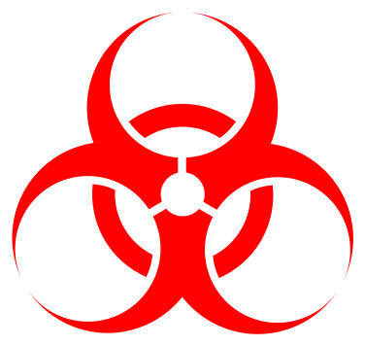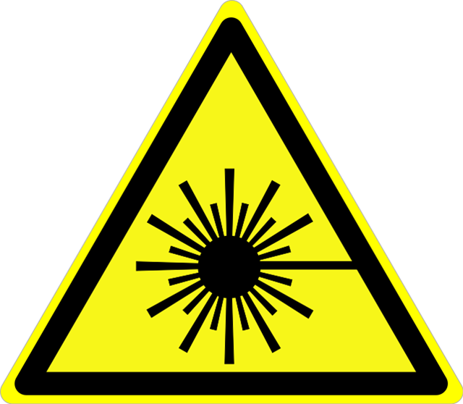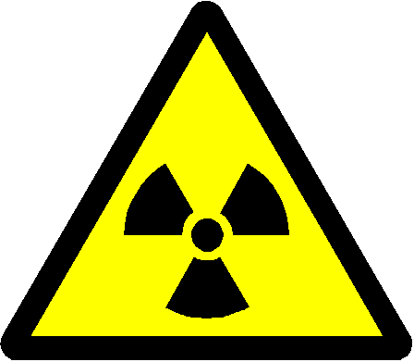

The hazards associated with biohazardous materials, lasers (Classes 3B and 4), and radioactive materials should be addressed in a lab-specific SOP. Additionally, general guidance on signage and safe handling of these materials is provided here.  
 **Biosafety**

1. Place biohazard warning signage on laboratory entrances, work surfaces for biohazardous material use, and biohazardous material storage areas.
2. Biosafety cabinets must be kept clean and orderly and tested at least annually.
3. All work surfaces shall be disinfected with 10% bleach after use, or if a spill is suspected.
4. Biohazardous waste must be autoclaved or disposed of as biohazardous waste in biohazard bags stored in a rigid container.

**Laser Safety**

1. Place laser warning signage on laboratory entrances, and clearly mark the nominal hazard zone (NHZ) if applicable.
2. Eye protection appropriate for the type of laser should be available and used by laboratory personnel.
3. For Class 4 lasers, a laser-in-use warning system for personnel entering the laboratory should be in place. Additionally, the system must have an emergency off switch accessible to users.
4. The beam path should be set up to avoid intersecting doors or windows, and to be off-set from high-traffic areas and eye level.

**Radiation Safety**

1. Place radiation warning signage on laboratory entrances, work surfaces for radioactive material use, and radioactive material storage areas.
2. Additional PPE and/or shielding should be available and used as needed by laboratory personnel.
3. Wipe tests should be performed for active use areas, potentially contaminated areas, and the exterior surfaces of radioisotope storage areas.
4. An accurate inventory of radioisotopes present in the lab, including the received dates and elapsed half-lives, should be available at all times.

## Sa***fety Data Sheets (SDSs)***

The Hazard Communication Standard requires that manufacturers and distributors of hazardous materials provide safety data sheets (SDSs) for all hazardous materials. The SDS provides detailed health and safety information about the specific chemical and makes recommendations for proper handling and PPE. Prior to using any hazardous chemical, consult the SDS. In order to fulfill regulatory obligations and ensure that all necessary SDSs are available, an accurate chemical inventory shall be maintained for all chemicals.

The SDS is broken down into 16 sections:

1. **Identification.** This section states the names and identification numbers for the material in question, as well as the supplier’s contact information.
2. **Hazard(s) Identification.** This section provides the Globally Harmonized System (GHS) classification for the material in question. Both the specific hazard and precautionary statements associated with the material and the GHS pictograms are provided. This section may include NFPA or HMIS ratings as well.
3. **Composition/Information on Ingredients.** This section describes the components of the material and their concentrations. Trade-secret materials or concentrations for chemicals that do not pose a health hazard may not be specified.
4. **First Aid Measures.** This section describes the appropriate first aid for exposure to the material and makes recommendations for medical care.
5. **Fire-Fighting Measures.** This section provides recommendations for extinguishing equipment and specific hazards associated with the material in case of a fire.
6. **Accidental Release Measures.** This section recommends responses to spills, including emergency procedures and appropriate clean up methods.
7. **Handling and Storage.** This section describes the precautions for safe handling and storage conditions.
8. **Exposure Controls/Personal Protection.** This section gives the OSHA Permissible Exposure Limits (PELs), ACGIH Threshold Limit Values (TLVs) and other exposure limits for the material, as well as recommendations for appropriate engineering controls and PPE.
9. **Physical and Chemical Properties.** This section provides physical and chemical properties of the material.
10. **Stability and Reactivity.** This section describes the reactivity and stability of the material, including incompatible conditions or materials and potential decomposition products.
11. **Toxicological Information.** This section provides specific data on the toxicity of the material, and details the potential routes of exposure and symptoms.
12. **Ecological Information.** This section evaluates the environmental effects of a potential spill or release of the material.
13. **Disposal Considerations.** This section recommends disposal practices, containers, and special precautions for waste disposal.
14. **Transport Information.** This section provides information on the shipping and transportation requirements for the material, as well as any transport-specific hazards.
15. **Regulatory Information.** This section includes any relevant regulatory information not indicated elsewhere on the SDS.
16. **Other Information.** This section contains the revision date for the SDS, as well as any other information the manufacturer chooses to include.

|  |  |  |
| --- | --- | --- |
| Health Hazard Health Hazard   * Carcinogen * Mutagenicity * Reproductive Toxicity * Respiratory Sensitizer * Target Organ Toxicity * Aspiration Toxicity | Flame Flame   * Flammables * Pyrophorics * Self-Heating * Emits Flammable Gas * Self-Reactives * Organic Peroxides | Exclamation Mark Exclamation Mark   * Irritant (skin and eye) * Skin Sensitizer * Acute Toxicity (harmful) * Narcotic Effects * Respiratory Tract Irritant * Hazardous to Ozone Layer |
| Gas Cylinder Gas Cylinder   * Gases under pressure | Flame Over Circle Flame Over Circle   * Oxidizers | Environment Environment (Non-Mandatory)   * Aquatic Toxicity |
| Skull and Crossbones Skull and Crossbones   * Acute Toxicity (fatal or toxic) | Exploding Bomb Exploding Bomb   * Explosives * Self-Reactives * Organic Peroxides | Corrosion Corrosion   * Skin Corrosion/Burns * Eye Damage * Corrosive to Metals |

# Chemical Hazard Classifications

Under the OSHA Hazard Communication Standard, which uses the United Nations Globally Harmonized System of Classification and Labeling of Chemicals (GHS), the hazards posed by chemicals are classified as physical or health hazards, and assigned to the categories described below.

## Health and Environmental Hazards

**Acute Toxicity** is defined by the LD50 or LC50 for a given material. Based on these values, acutely toxic materials are assigned a category of 1-5, with 1 being the most acutely toxic, and 5 being the least.

**Skin Corrosion** refers to irreversible skin damage caused by direct exposure to a material.

**Skin Irritation** refer to reversible skin damage or inflammation caused by direct exposure to a material.

**Eye Effects** includes both ***serious eye damage***, the occurrence of tissue damage or loss of vision or visual acuity due to exposure to a material, and ***eye irritation***, changes to the eye that resolve within 21 days.

**Sensitization** includes both ***respiratory sensitization***, the hypersensitivity of the respiratory system after exposure to a material, and ***skin sensitization***, the allergic reaction of the skin caused by exposure to a material.

**Germ Cell Mutagenicity** is the increased incidence of heritable mutations occurring as a result of exposure to a material.

**Carcinogenicity** is the increased incidence of cancer or tumor development occurring as a result of exposure to a material.

**Reproductive Toxicity** refers to increased incidence of infertility, sexual dysfunction, or offspring developmental toxicity occurring as a result of exposure to a material.

**Target Organ Systemic Toxicity** refers to systemic health effects, narcotic effects, respiratory tract irritation, and any other significant health effect not addressed elsewhere in the GHS classification system; this includes reversible or irreversible effects, immediate or delayed symptoms, and single or repeated exposures.

**Aspiration Toxicity** is the occurrence of significant health effects or injury to the respiratory system following the inhalation or entry of a material into the respiratory tract.

**Acute Aquatic Toxicity** is the capacity of a material to induce significant injury to aquatic organisms or ecosystems from a single or short-term exposure.

**Chronic Aquatic Toxicity** is the capacity of a material to induce significant injury to aquatic organisms over the lifetime of an organism.

## Physical Hazards

**Explosives** are materials which, without the addition of other materials, can potentially generate gas such that they can cause direct physical damage to their surroundings. This classification also includes pyrotechnic materials that do not produce gases.

**Flammable Gases** are gases that have a flammable range at 20°C and 101.3kPa in ambient air.

**Flammable Aerosols** are pressurized compressed, liquefied, or dissolves gases in non-refillable containers designed to release their contents in suspension. Aerosols are considered flammable unless they contain ≤1% flammable material and have a heat of combustion of <20 kJ/g.

**Oxidizing Gases** are gases which may intensify fire by providing oxygen.

**Gases Under Pressure** are gases either pressurized to ≥280 Pa at 20°C, or stored as a refrigerated liquid.

**Flammable Liquids** are liquids with a flash point of ≤93°C.

**Flammable Solids** are solids that can be easily ignited by friction or by brief contact with an ignition source.

**Self-Reactive Substances** are materials that may react spontaneously to decompose in an exothermic reaction.

**Pyrophoric Liquids** are liquids that may ignite within 5 minutes of being in contact with air, regardless of quantity.

**Pyrophoric Solids** are solids that may ignite within 5 minutes of being in contact with air, regardless of quantity.

**Self-Heating Substances** are materials that do not fall under the pyrophoric classification, but in which in large quantities may ignite after extended contact with air.

**Substances Which in Contact with Water Emit Flammable Gases** are materials that either become flammable or give off flammable gases when in contact with water.

**Oxidizing Liquids** are liquids which may intensify fire by providing oxygen.

**Oxidizing Solids** are solids which may intensify fire by providing oxygen.

**Organic Peroxi**des are organic materials which contain an R–O-O-H or R-O-O-R structure; these materials are frequently shock sensitive, may decompose explosively, and can be reactive.

**Substances Corrosive to Metal** are materials which may corrode or damage metals that they come in contact with.

Particularly Hazardous Substances (PHSs)  
Particularly Hazardous Substances are materials for which the OSHA Laboratory Safety Standards mandates lab-specific SOPs. PHSs include select carcinogens, reproductive toxins, and materials with a high degree of acute toxicity (CFR 1910.1450(e)(3)(viii). See the **Lab Specific SOP Template** appendix for an example format.

# Hazardous Waste

**Disposal Overview**

1. Do not discard hazardous chemical, biological, or radioactive materials in the trash or sink.
2. Any water or solvent used to rinse contaminated glassware or equipment should be treated as hazardous waste.
3. Dispose of empty containers of extremely hazardous substances, or those larger than 5 gallons, as hazardous waste.
4. Thoroughly rinse empty chemical storage containers (not for extremely hazardous substances, <5 gallons), deface the label, and dispose of the container as trash or in a glass disposal bin depending on the material.
5. Unless emptied (either by spraying until completely emptied or by puncturing) aerosol cans must be disposed of as hazardous waste.

**Labeling and Containers**

1. Label all hazardous waste containers with their contents, hazards, accumulation start date, physical state, location, and generator information (name, address, and EPA ID) **when the first drop of waste is generated**. See the **Hazardous Waste Label** appendix for format, or download the fillable PDF from the Pomona EH&S website.
2. Hazardous waste containers should be clean, in good condition, and made of a material compatible with their contents. Dry waste should be double bagged in clear plastic bags.
3. To prevent overflows, do not fill hazardous waste containers above 90%.
4. Do not combine incompatible waste streams in one container.
5. Do not combine waste streams with different physical states in one container.

**Storage and Containment**

1. Designate a specific location in the laboratory for hazardous waste storage.
2. Store hazardous waste containers in secondary containment with the cap or lid closed unless actively adding waste.
3. Do not store containers of incompatible hazardous chemical waste together; consult the SDS for the waste components to determine compatibility. Also see the **Chemical Incompabitility Matrix** appendix.
4. Do not store hazardous waste containers beyond 180 days; each department will coordinate a location and time for hazardous waste pickup every 90 days.

# Laboratory Injuries

## Students

**Non-Urgent: No Medical Treatment Required**  
 1) Principal Investigator attends to the injured student.

2) The Principal Investigator must fill out the “**Accident Investigation Form**.”

3) The Principal Investigator will email a scanned copy of the form to the EH&S Officer and file the form in the Laboratory Safety Binder.

**Non-Urgent: Medical Treatment Required** 1) Principal Investigator attends to the injured student.

2) Call campus safety at x72000 to report the incident and request that campus safety notify the On-Call Dean from the respective colleges. Campus safety can come to the scene and provide necessary emergency treatment and/or transport to Student Health Services.

* Indicate to campus safety the nature of emergency and give the exact location where the incident occurs.

3) The Principal Investigator must fill out the “**Accident Investigation Form**” and notify the EH&S Officer within 8 hours of the incident. The EH&S Officer will inform the department chair, the Dean’s Office, and the Communications Office.

4) The Principal Investigator will email a scanned copy of the form to the EH&S Officer and file the form in Laboratory Safety Binder. The EH&S Officer will generate a report and “lessons learned” document for distribution.

**Urgent: Medical Treatment Required** 1) Principal Investigator attends to the injured student.

2) Call campus safety at x72000 to report the incident and request that campus safety notify the On-Call Dean from the respective colleges. Campus safety will call paramedics **if** warranted and/or come to the scene and provide necessary emergency treatment.

* Indicate to campus safety the nature of emergency and give the exact location where the incident occurs.

3) The Principal Investigator must fill out the “**Accident Investigation Form**” and notify the EH&S Officer within 8 hours of the incident. The EH&S Officer will inform the department chair, the Dean’s Office, and the Communications Office.

4) The Principal Investigator will email a scanned copy of the form to the EH&S Officer and file the form in Laboratory Safety Binder. The EH&S Officer will generate a report and “lessons learned” document for distribution.

## Employees (includes Student Workers)

**Non-Urgent: No Medical Treatment Required**  
1) Principal Investigator attends to the injured worker.

2) The Principal Investigator must fill out the “**Accident Investigation Form**.”

3) The Principal Investigator will email a scanned copy of the form to the EH&S Officer and file the form in the Laboratory Safety Binder.

4) Student workers can seek health services if needed. They can make an appointment with the Claremont Colleges Student Health Services. Please see below for more information.

* If medical treatment is requested, notify the **Worker’s Compensation Administrator** at x18847.
* Student workers must obtain authorization from the Worker’s Compensation Administrator or the Human Resources office before receiving medical treatment for any work-related injury.

5) An “**Employee’s Report of Accident**” and a “**Supervisor’s Report of Accident**” MUST be completed as soon as possible and submitted to the Worker’s Compensation Administrator and to the Pomona College Human Resources Office even if medical treatment is declined.

**Non-Urgent: Medical Treatment Required** 1) Principal Investigator attends to the injured worker.

2) Call campus safety at x72000 to report the incident and request that campus safety notify the On-Call Dean from the respective colleges. Campus safety can come to the scene and provide necessary emergency treatment and/or transport to health services.

* Indicate to campus safety the nature of emergency and give the exact location where the incident occurs.
* If medical treatment is requested, notify the **Worker’s Compensation Administrator** at x18847.
* Staff or student workers must obtain authorization from the Worker’s Compensation Administrator or the Human Resources office before receiving medical treatment for any work-related injury.

3) The Principal Investigator must fill out the “**Accident Investigation Form**” and notify the EH&S Officer within 8 hours of the incident. The EH&S Officer will inform the department chair, the Dean’s Office, and the Communications Office.

4) The Principal Investigator will email a scanned copy of the form to the EH&S Officer and file the form in Laboratory Safety Binder. The EH&S Officer will generate a report and “lessons learned” document for distribution.

5) An “**Employee’s Report of Accident**” and a “**Supervisor’s Report of Accident**” MUST be completed as soon as possible and submitted to the Worker’s Compensation Administrator and to the Pomona College Human Resources Office.

**Urgent: Medical Treatment Required** 1) Principal Investigator attends to the injured worker.

2) Call campus safety at x72000 to report the incident and request that campus safety notify the On-Call Dean from the respective colleges. Campus safety will call paramedics **if** warranted and/or come to the scene and provide necessary emergency treatment and/or transport to the Student Health Services.

* Indicate to campus safety the nature of emergency and give the exact location where the incident occurs.
* If medical treatment is requested, notify the **Worker’s Compensation Administrator** at x18847.
* Staff or student workers must obtain authorization from the Worker’s Compensation Administrator or the Human Resources office before receiving medical treatment for any work-related injury.
* 3) The Principal Investigator must fill out the “**Accident Investigation Form**” and notify the EH&S Officer within 8 hours of the incident. The EH&S Officer will inform the department chair, the Dean’s Office, and the Communications Office.
* 4) The Principal Investigator will email a scanned copy of the form to the EH&S Officer and file the form in Laboratory Safety Binder. The EH&S Officer will generate a report and “lessons learned” document for distribution.
* 5) An “**Employee’s Report of Accident**” and a “**Supervisor’s Report of Accident**” MUST be completed as soon as possible and submitted to the Worker’s Compensation Administrator and to the Pomona College Human Resources Office.

## Available Medical Services

**If Student Health Services is closed when an injury occurs and where non-urgent medical attention is required, the On-Call Dean from the respective colleges will transport the student to the nearest medical center.**

***Student Health Services (Tranquada)***  
757 College Way, Claremont, CA 91711 (in front of Honnold Library)  
(909) 621-8222 (On campus–ext. 18222)  
Fax: (909) 621-8472  
  
M-F (while classes are in session): 8:00 a.m.- 5:00 p.m. (7:00 p.m. on Wednesdays)  
**Appointments are highly recommended for all visits.**

1. Appointments begin at 8:30 a.m. and can be made starting at 8:00 a.m. by telephone.
2. Same-day appointments are usually available if you call early.
3. Students do not have to pay for charges at the time of service.
4. A $10 charge will be assessed for any missed appointments not canceled two hours in advance.
5. Walk-in visits are available Monday through Friday at 8:30 a.m.– 10:30 a.m. and 2:00 p.m.  4:00 p.m. Walk-in students are seen in the order of arrival and are worked into the schedule between appointments. Be prepared to wait. There is a $10 charge for walk-in visits.

***Pomona Valley Health Centers Urgent Care***1601 Monte Vista Avenue, Ste. 190Claremont, CA 91711 909-865-9977

8:00 a.m. - 8:00 p.m. Monday through Friday  
9:00 a.m. - 5:00 p.m. weekends and holidays

# Earthquakes

In California, earthquakes are always a major safety concern and could happen without warning at any time. The key to preventing injuries or property damage is preparation.

**Earthquake Preparation Checklist**

The following is a checklist designed to help your laboratory prepare for an earthquake:

**Chemicals:**

Are chemicals capped and returned to the storage after use?

Are chemical storage cabinets closed and latched?

Is there a designated area for storage of hazardous chemical waste?

Are incompatible chemicals stored separately?

Is chemical storage above eye level minimized?  
Are chemical and waste in secondary containment trays or tubs?

**Equipment & Furniture:**

Are compressed gas cylinders capped when not in use?

Are gas cylinders secured in an upright position and chained to the wall or very stable structure?

Are chemical storage cabinets secured to the wall to prevent tipping or movement?

Are chemical storage shelves equipped with lips or restraints to keep chemicals and glassware in place?

Are exits and aisles maintained free and clear of obstructions?

Is heavy equipment or furniture that might block exit route secured?

Is safety equipment (fire extinguishers, safety showers, eyewashes) accessible and in working condition?

Is storage of breakable items such as glassware on open benches or shelves minimized?

**Personal Preparation**

Do you know the emergency assembly point (EAP) for your building?

Can you identify danger spots (windows, chemical shelves, and objects or equipment which may fall)?

Can you identify safe spots to shelter in case of an earthquake (sturdy desk, table, or the laboratory bench)?

Do you know the evacuation routes for your building?

Do you have an emergency supply kit that includes flashlight, food, water, essential medicines, study shoes, and etc… that will last for at least 72 hours?

Do you have a listing of emergency numbers?

Have you undergone training first aid and CPR?

**Earthquake Procedures**

**During an Earthquake**

a) If you are inside the laboratory, move away from windows, chemical shelves, and objects or equipment which may fall.

b) Take cover underneath a sturdy desk, table, or the laboratory bench (**Drop, Cover, and Hold)**.

c) Be aware that the electricity may go out or the fire alarms or the sprinkler system may be activated.

c) If you are outdoors, stay away from power lines, tall building, and trees.

d) Do not leave the building until the shaking has stopped.

**After the Earthquake**

a) Be prepared for aftershocks.

b) Account for people who were in the lab with you when the disaster struck.

c) Check for injured people who might have trouble evacuating the building

d) Check for fire hazards or spilled chemicals.

e) If it is safe to extinguish the fire, do so.

f) If it is possible and safe, contain any chemical spills and turn off ignition sources.

g) Evacuate to the Emergency Assembly Area, closing doors behind you.

h) When leaving the building, use the stairs instead of the elevator.

# Laboratory Fires

A fire within the classroom and/or laboratory can grow in both size and severity due to storage of flammable or other hazardous chemicals. Careful consideration must be made when attempting to extinguish a fire of any size. Never use a fire extinguisher if you have never been trained or do not feel comfortable. Never enter a room alone during a fire, or enter a room that is smoke filled.

Before using a fire extinguisher, you need to make an assessment of the fire. If the fire is larger than the size of a regular office trash can, do not try to extinguish the fire using the fire extinguisher. Moreover, do not use a fire extinguisher for a gas fire fueled by open valve or broken line; shut down the source before extinguishing the fire.

**Fire Prevention & Preparation**

The following are ways to minimize the risk of a laboratory fire occurring:

a) Keep laboratory door closed at all times.

b) Minimize the amount of flammable liquids inside a laboratory

* Do not store more than 25 gallons of flammable liquids inside the flammable storage cabinet.
* Do not store more than 5 gallons of flammable liquids on the lab bench outside the flammable storage cabinet.

c) Minimize the amount of combustible materials inside the laboratory.

d) Do not store flammable or combustible chemicals near ignition sources.

In case of a fire, all laboratory personnel should:

a) Know the location of the fire extinguisher.

b) Familiarize yourself with the map of each building. The map is usually located near building exit or elevator.

c) Know the location of the fire alarm pull station.

d) Know exit routes and stairway.

e) Learn how to use a fire extinguisher.

f) Know building’s emergency assembly point (EAP)

**Small Fire:**

A small fire is a fire that is smaller than the size of a regular office trash can. The following procedure can be used during a small fire:

1) Alert the people in the surrounding area of the fire.

2) Identify someone to call campus safety by dialing x72000, or if you are alone then make the call yourself.

3) A fire within a **contained vessel** can easily be smothered, if it is safe to do so.

4) Use a fully operational fire extinguisher to extinguish a small fire.

5) Once you completely extinguish the fire, report this incident to the Environmental Health and Safety Officer.

**Large Fire:**

A large fire is a fire that is larger than the size of a regular office trash can. Do not try to extinguish large fire using a fire extinguisher. The following procedures can be used in the event of a large fire:

1) Alert people in the surrounding area of the fire.

2) Exit the lab and contain the fire by closing the lab’s door. If the fire occurs in the fume hood, close the hood’s sash.

3) Activate the nearest alarm pull station.

4) Locate the nearest safe campus phone and call Campus Safety at x72000 or (for cell phones) call (909) 607-2000.

5) Evacuate the building using the stairwells. Never use the elevator to exit the building during a fire.

6) Do not re-enter the building without campus safety authorization.

**Clothing on Fire:**

1) When your clothes catch on fire, the best course of action is to “**Stop-Drop-Roll-Roll-Roll.”** This will help to smother the fire. Protect your face with your hands. During this time, remember to yell for help!

2) Use safety shower or fire extinguisher only if they are immediately available.

3) Seek medical attention when burned.

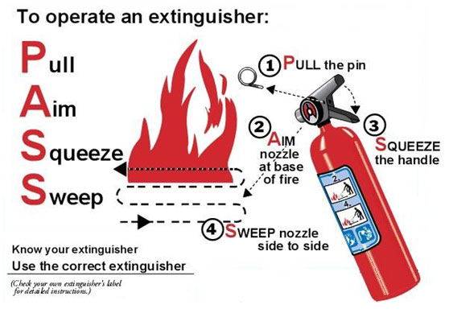

**Fire Alarms**

A fire alarm means “**evacuate**.” A fire alarm or flashing strobe lights is a warning of a fire nearby. They may also indicate a drill, or a false alarm. Whatever the situation may be, act as if there is an actual fire and evacuate the building. If you detect a smoke or fire, remember the acronym **RACER**. Keep in mind that these steps do not need to be followed in sequential order. Assess the situation and determine the appropriate course of action.

**R**escue:

1) Rescue people near the smoke and/or fire. If someone is on fire, help them to “**stop-drop-roll-roll-roll.”**

**A**larm:

1) Alert people in the surrounding area of the fire.

2) Activate the nearest fire alarm pull station.

3) Contact campus safety using a campus phone and dial x72000 or (for cell phones) call (909) 607-2000 and provide your name and location.

**C**ontain:

1) Contain the smoke and/or fire by closing the doors to labs, rooms, stairwells, corridors, and windows. If the fire occurs in the fume hood, lower the hood’s sash.

2) Turn off all ignition sources (open flame, electrical devices).

**E**xtinguish or **E**vacuate:

Extinguish the fire using the appropriate fire extinguisher. If you have not been trained or feel comfortable using a fire extinguisher, then evacuate the building. Also, if the fire is larger than the size of regular office’s trash can, then do not attempt to extinguish the fire using the fire extinguisher. Evacuate if necessary.

**R**elocate:

1) Relocate to the Emergency Assembly Point.

2) Wait for Campus Safety to arrive.

3) Do not re-enter the building without campus safety permission.

**Fire Classification:**

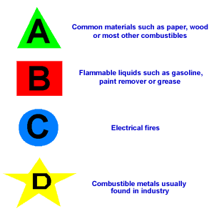

# Chemical Spills

Chemical spills must be cleaned up immediately by trained personnel. Clean up a chemical spill only if the following conditions are met:

a) You know what the chemicals are and what hazards they pose.

b) You understand the clean up protocols and you have adequate clean up materials in the laboratory.

c) You have the proper Personal Protective Equipment (PPE) to do the clean up.

d) If you feel comfortable and feel that no personal injuries will result from cleaning the spill.  
e) There is no secondary situation (e.g. a fire) present.

Minor Chemical Spills**:**

A minor chemical spill is a spill in which you can clean up in about 5-10 minutes and the quantity of the spill is less than 500 mL. In an event of a minor chemical spill in which there is no potential for exposure, you can do the clean up. Some factors that you want to consider when doing the cleaning are:

a) The size area and quantity of the spill

b) The availability of clean up equipment in the laboratory

c) The toxicity and hazardous properties of the chemical

d) Personal exposure to the chemical

**Minor Chemical Spill Procedures:**

1) Alert people in the surrounding immediately of the spill.

2) Help anyone who has been contaminated. Use the emergency shower/eyewash and flush skin or eye for about 15 minutes.

3) Check the SDS and/or container label for proper personal protective equipment to wear and procedures for cleaning up the spill. Contact the Environmental Health and Safety Officer if needed.

4) Turn off all ignition sources (flames, electrical devices) near the spill area.

5) Confine the spill to small area. Do not let it spread.

6) Use the appropriate spill kit to absorb the spill. Collect the residue in a clear plastic bag and dispose of it as hazardous chemical waste. Do not dispose the chemical or any contaminated clean up materials in the sink or in the trash can.

8) Clean the spill area with soap and water. Treat the water and any additional clean up materials as hazardous chemical waste.

9) **DO NOT CLEAN UP THE SPILL BY YOURSELF. HAVE A TRAINED PARTNER WITH PPE HELP YOU DO THE CLEAN UP.**

**Minor Radiation Spill Procedures**

1. Alert people in the area of the spill.
2. Limit access to the spill area to those staff needed for cleanup purposes.
3. Do not allow anyone to leave contaminated area without first being monitored for contamination using the appropriate survey meter or method. If contamination is found, have the staff change clothing as necessary. Then re-monitor to ensure no radiation is found on the person.
4. Wear personal protective equipment, including safety goggles, gloves, shoe covers, and long-sleeve lab coat to begin the decontamination process.
5. Place absorbent paper towels over the spill area. If spill is a solid material, then place towel soaked with water over the spills.
6. Place the towels in a clear plastic bag using a forceps or equivalent. Dispose in radioactive waste box.
7. Gently wash the spilled area using normal cleaning agents or commercial decontamination agents.
8. Discard all used cleaning materials as radioactive waste.
9. Repeat cleaning procedure until all radioactive material is removed.
10. Get monitored for possible contamination.

Major Chemical Spills:

For a major chemical spill, do not attempt to clean up the spill. Report major chemical spills to campus safety at x72000. Notify the Environmental Health and Safety Officer immediately.

**Major Chemical Spill Procedures**:

1. Notify people in the area immediately of a chemical spill.
2. Attend to the injured or contaminated person in the area. Use the emergency shower/eyewash and flush skin or eye for about 15 minutes.
3. Turn off all ignition sources (flames, electrical devices) if it is safe to do so.
4. Confine the spill if it is safe and you feel comfortable doing so.
5. Evacuate the laboratory and close the door.
6. Call Campus Safety by dialing X72000 and notify the Environmental Health and Safety Officer immediately.

**Chemical Spill Outside the Laboratory**

1. When transporting chemicals, use a secondary container. If a chemical spill occurs, do not try to clean the spill without any personal protective equipment. Any spill outside of the laboratory should be considered a major spill and be reported immediately.
2. Secure the area and notify the people around of the spill. Do not let anyone get near the spill.
3. Call Campus Safety at x72000 and notify the Environmental Health and Safety Officer of the spill immediately.

**Major Radioactive Material Spill**

1. Alert people in the area of a spill. Have people not involved in the spill or near the spill to leave the area immediately.
2. Do not allow anyone to leave contaminated area without first being monitored for contamination using the appropriate survey meter or method. If contamination is found, have the staff change clothing as necessary. Then re-monitor to ensure no radiation is found on the person.
3. Close and lock laboratory doors and post a sign to prevent entry.
4. Call campus safety from a lab phone by dialing X72000. Notify the Environmental Health and Safety Officer immediately.

## Personnel Exposure

**Hazardous Chemical Spill on a Person**

1. Enter the emergency shower and flush the affected area with water for 15 minutes. Remove contaminated clothing and consider it to be hazardous waste.
2. Call campus safety at x72000 to report the incident and request campus safety to notify the On-Call Dean from the respective colleges. Campus safety will call paramedics **if** warranted and/or come to the scene and provide necessary emergency treatment and/or transport for medical treatment.
3. Bring the SDS of the spilled chemical with you and present it to the doctor in attendance.
4. Follow reporting requirements under the Laboratory Injuries section.

**Cryogenic Liquid Spill on the Skin**

1. Cryogenic liquids may cause crystal to develop under tissues of the affected area. When cryogenic liquids spill on the skin, re-warm the affected area with warm water (not with hot water).
2. Call campus safety at x72000 to report the incident and request campus safety to notify the On-Call Dean from the respective colleges. Campus safety will call paramedics **if** warranted and/or come to the scene and provide necessary emergency treatment and/or transport for medical treatment.
3. Bring the SDS of the spilled material with you and present it to the doctor in attendance.
4. Follow reporting requirements under the Laboratory Injuries section.

**Hazardous Chemical Splash into Eyes**

1. Immediately flush the eye(s) with water for 15 minutes using the emergency eye wash station.
2. Call campus safety at x72000 to report the incident and request campus safety to notify the On-Call Dean from the respective colleges. Campus safety will call paramedics **if** warranted and/or come to the scene and provide necessary emergency treatment and/or transport for medical treatment.
3. Bring the SDS of the spilled material with you and present it to the doctor in attendance.
4. Follow reporting requirements under the Laboratory Injuries section.

**Radioactive Spill on a Person**

1. Remove contaminated clothing and rinse the exposed area thoroughly.
2. Get monitored for contamination using the appropriate survey meter or method to ensure no radiation is found.
3. Follow reporting requirements under the Laboratory Injuries section.

# Appendix A: Medical Consultation/Surveillance

All staff and faculty working with hazardous chemicals will be provided with an opportunity to have medical examination, and follow-up examination, if necessary, under any of the following circumstances:

1) The employees develop signs and symptoms of overexposure associated with the chemical to which they may have been exposed in the laboratory.

2) For specific substances regulated by Cal/OSHA (particularly hazardous substances) where environmental monitoring demonstrates routine exposure above the action level.

3) Employee exposure to hazardous chemicals in the event of a spill, leak, or explosion.

In the event of an uncontrolled release of a hazardous material where there is likelihood that the individual may have been overexposed to the hazardous material, the following information is required:

1) The identity of the hazardous material to which the employee may have been exposed.

2) A description of the conditions under which the exposure occurred including, if available, quantitative exposure data.

3) A description of the signs and symptoms of exposure.

4) A copy of the material safety data sheets for the chemical(s) involved.

The physician will provide a written opinion that will not reveal specific findings or diagnosis unrelated to the exposure, but will include:

1) Any recommendation for further medical follow-up.

2) Results of medical examination and any associated tests.

3) Any medical conditions that may be revealed in the course of the examination that may place the employee at increased risk as a result of exposure to a hazardous chemical found in the workplace.

4) A statement by the physician that the employee has been informed of the consultation/examination results and any medical condition that may require further examination or treatment.

# Appendix B: Lab-Specific SOP Template

**Overview**

Provide an overview of the hazards posed by the chemical or process and the most important safety information.

**Personal Protective Equipment (PPE)**

1. **Body Protection:**
2. **Gloves:**
3. **Eye Protection:**

**Standard Procedures**

Describe the general laboratory safety procedures for handling the material or performing the process. Include necessary engineering controls, specific warnings or potential hazards, and other general guidance.

Provide the step-by-step, lab-specific procedure that the user will be following in sufficient detail to complete the procedure as written.

**Emergency Procedures**

Whenever seeking treatment for a chemical exposure, bring a copy of the SDS and show it to the doctor in attendance.

**Skin Exposure:**

**Eye Exposure:**

**Inhalation:**

**Minor spill:**

**Large spill:**

**Hazardous Waste Disposal**

Describe any specific waste procedures or safety guidance.

**Acknowledgment**

This SOP has been reviewed and approved by:

**_____________________________ ________________________________ _________**Supervisor Name Supervisor Signature Date

By signing below, you acknowledge that you have reviewed this SOP in its entirety, will follow all safety guidance set out both in the SOP and in the campus CHP, and have reviewed the safety data sheets for the associated chemicals.

|  |  |  |  |
| --- | --- | --- | --- |
| **Name** | **Signature** | **Date** | **Supervisor Initial** |
|  |  |  |  |
|  |  |  |  |
|  |  |  |  |
|  |  |  |  |
|  |  |  |  |
|  |  |  |  |
|  |  |  |  |
|  |  |  |  |
|  |  |  |  |
|  |  |  |  |
|  |  |  |  |
|  |  |  |  |
|  |  |  |  |
|  |  |  |  |

# *Appendix C: Emergency Eyewash and Safety Shower Program*

*TBD*

# Appendix D: Accident Investigation Form

**1. Who was injured?**

Name: ________________________________________ Male Female

Last First Middle

Home Address: __________________________________

City: ______________________ State: __________ Zip: ________

Telephone: _____________________ Date of Birth: ___________

**2. When and where did this happen?**

Date of Injury: _____________ Time of Injury: ______ Date Reported: ______

Location where injury occurred (building, room): _______________________

**3. How did this happen?** What was the injured doing at the time of the injury? Describe events immediately preceding the injury. List all objects and substances involved.

**4. What injuries resulted?** Type of injuries and body part(s) injured. Example: “sprained ankle.”

**5. Was medical treatment needed?**

Was first aid administered? Yes No If yes, who administered it?: ______

Did injured person go to clinic or hospital? Yes No

If yes, describe medical treatment received:

Who accompany the injured person to the clinic/hospital: ______________

Doctor’s Name: ____________ Name of Medical Facility: ________________

Phone: _____________

**6. Was the injured person wearing any personal protective equipment? If so, list all PPE worn.**

**7. Were there any witnesses?** Yes  No

Name of witness: ______________ Phone number: ___________

Witness description of the incident:

Witness signature: ____________________________

**8. How could this accident have been prevented?**

Summary of key finding that contribute to the injury:

Was the injured person trained to perform this task safely? Yes No

If yes, do you have training record? Yes No

Action taken to prevent a recurrence of this injury/accident:

Supervisor Name: ________________________

Supervisor Signature: _____________________ Date: ___________________

**Once the form has been completed, email a scanned copy of the form to the Environmental Health and Safety Officer and keep the original in the lab safety binder.**

This page intentionally left blank.

# Appendix E: Peroxide Formers

In order to limit the explosion potential created by peroxide formation in ethers and similar compounds, the following requirements must be satisfied:

1. **Container labeling** - In addition to the original manufacture label or secondary label, the container for all peroxide-formers (Class I, II and III as listed below) shall be labeled with the following

* “WARNING PEROXIDE FORMER” or “POTENTIAL EXPLOSIVE PEROXIDE”
* Date of purchase and opening date
* The required discard-by date, and the test-by date if applicable

1. **Disposal requirements** - The discard date is dependent on the type of peroxide former (table below).

* **Class A** should be discarded 3 months after opening. These chemicals form explosive levels of peroxides without concentration, especially after exposure to air. The discard date can be reset if tested for peroxide formation.
* **Class B** should be tested for peroxide formation 12 months after opening, then every 6 months. Discard promptly if not needed.
* **Class C** should be tested for peroxide formation 12 months after opening, then every 12 months. These chemicals may form explosive or shock sensitive peroxides.

|  |  |
| --- | --- |
| Class A | Butadiene*, Isopropyl ether, Sodium amide, Chloroprene*, Potassium amide, Tetrafluoroethylene*, Divinyl ether, Potassium metal, Vinylidene chloride |
| Class B | Acetal, Acetaldehyde, Benzyl alcohol, 2-Butanol, Cumene, Cyclohexanol, Cyclohexene, 2-Cyclohexen-1-ol, Decalin, Diacetylene gas, Dicyclopentadiene, Diglyme, Diethyl ether, Dioxanes, Ethylene glycol ether acetates, Furan, 4-Heptanol, 2-Hexanol, Methylacetylene gas, 3-Methyl-1-butanol, Methyl cyclopentane, Methyl isobutyl ketone, 4-Methyl-2-pentanol, 2-Pentanol, 4-Penten-1-ol, 1-Phenylethanol, 2-Phenylethanol, Tetrahydrofuran, Tetrahydronaphthalene, Vinyl ethers, and other secondary alcohols |
| Class C | Acrylic acid, Acrylonitrile, Butadiene gas, Chlorobutadiene, Chloroprene, Chlorotrifluoroethylene gas, Methyl methacrylate, Styrene, Tetrafluoroethylene gas, Vinyl acetate, Vinylacetylene gas, Vinyladiene chloride, Vinyl chloride gas, Vinyl pyridine |

*as a liquid monomer

# Appendix F: Hazardous Waste Tag Format

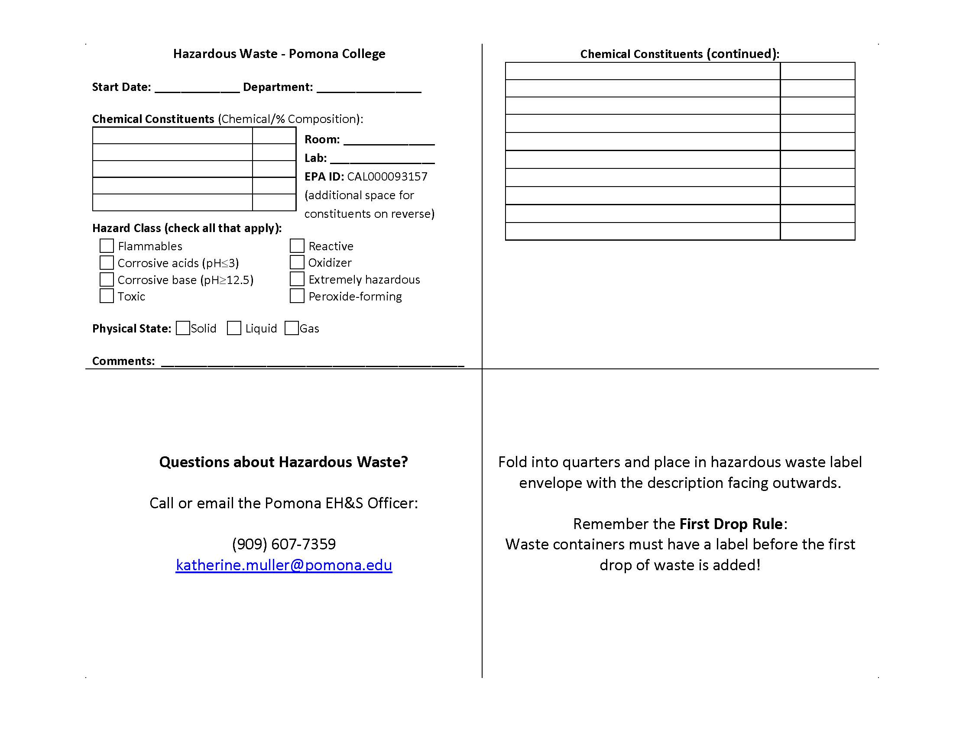

# Appendix G: General Chemical Incompatibility Matrix

Follow the specific incompatibility guidelines for a given chemical based on the information in Section 10 of the SDS. However, these rules hold generally for most chemicals and are a useful reference.

|  |  |  |  |  |  |  |  |  |  |
| --- | --- | --- | --- | --- | --- | --- | --- | --- | --- |
|  | **Acids, Inorganic** | **Acids, Oxidizing** | **Acids, Organic** | **Alkalis (Bases)** | **Oxidizers** | **Poisons, inorganic** | **Poisons, organic** | **Water reactives** | **Organic solvents** |
| **Acids, Inorganic** |  |  | **X** | **X** |  | **X** | **X** | **X** | **X** |
| **Acids, Oxidizing** |  |  | **X** | **X** |  | **X** | **X** | **X** | **X** |
| **Acids, Organic** | **X** | **X** |  | **X** | **X** | **X** | **X** | **X** |  |
| **Alkalis (Bases)** | **X** | **X** | **X** |  |  |  | **X** | **X** | **X** |
| **Oxidizers** |  |  | **X** |  |  |  | **X** | **X** | **X** |
| **Poisons, inorganic** | **X** | **X** | **X** |  |  |  | **X** | **X** | **X** |
| **Poisons, organic** | **X** | **X** | **X** | **X** | **X** | **X** |  |  |  |
| **Water reactives** | **X** | **X** | **X** | **X** | **X** | **X** |  |  |  |
| **Organic solvents** | **X** | **X** |  | **X** | **X** | **X** |  |  |  |

**X = Not compatible – do not store together**